Ideation Phase
Brainstorm & Idea Prioritization Template

Date | 30-09-2026
Team ID | SWTID-2026-5703
Project Name | AI-Augmented Backend Development AI FitTrack API
Maximum Marks | 4 Marks

Brainstorm & Idea Prioritization Template:
Brainstorming provides a free and open environment that encourages everyone within a team to participate in the creative thinking process that leads to problem solving. Prioritizing volume over value, out-of-the-box ideas are welcome and built upon, and all participants are encouraged to collaborate, helping each other develop a rich amount of creative solutions.
Use this template in your own brainstorming sessions so your team can unleash their imagination and start shaping concepts even if you're not sitting in the same room.
Reference: https://www.mural.co/templates/brainstorm-and-idea-prioritization
Step-1: Team Gathering, Collaboration and Select the Problem Statement
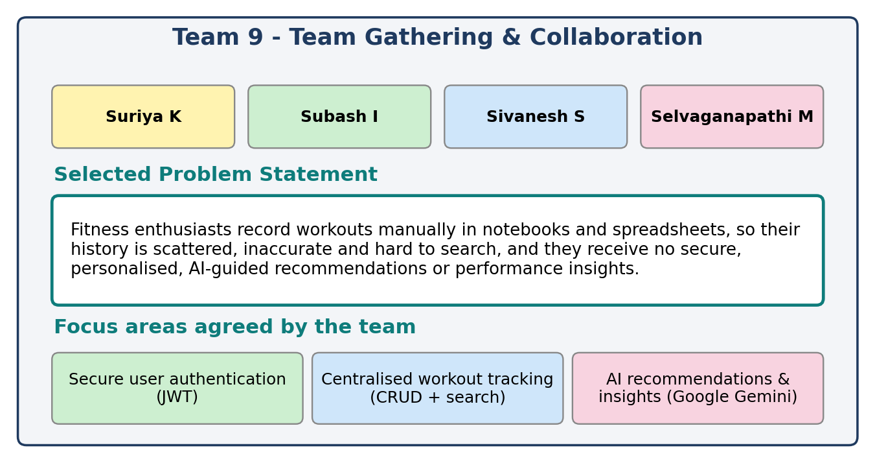

Step-2: Brainstorm, Idea Listing and Grouping
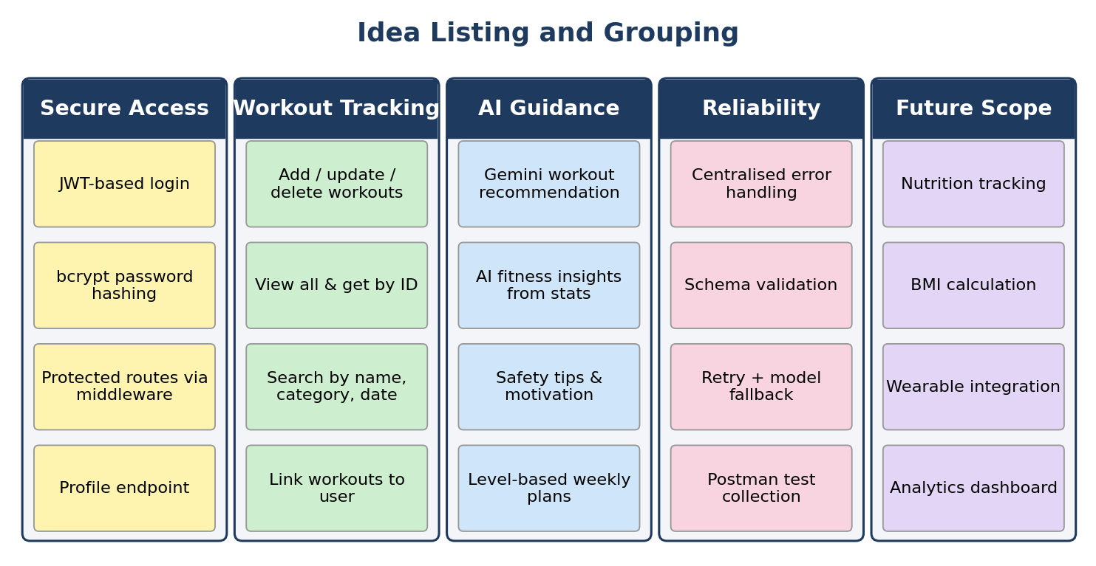

Step-3: Idea Prioritization
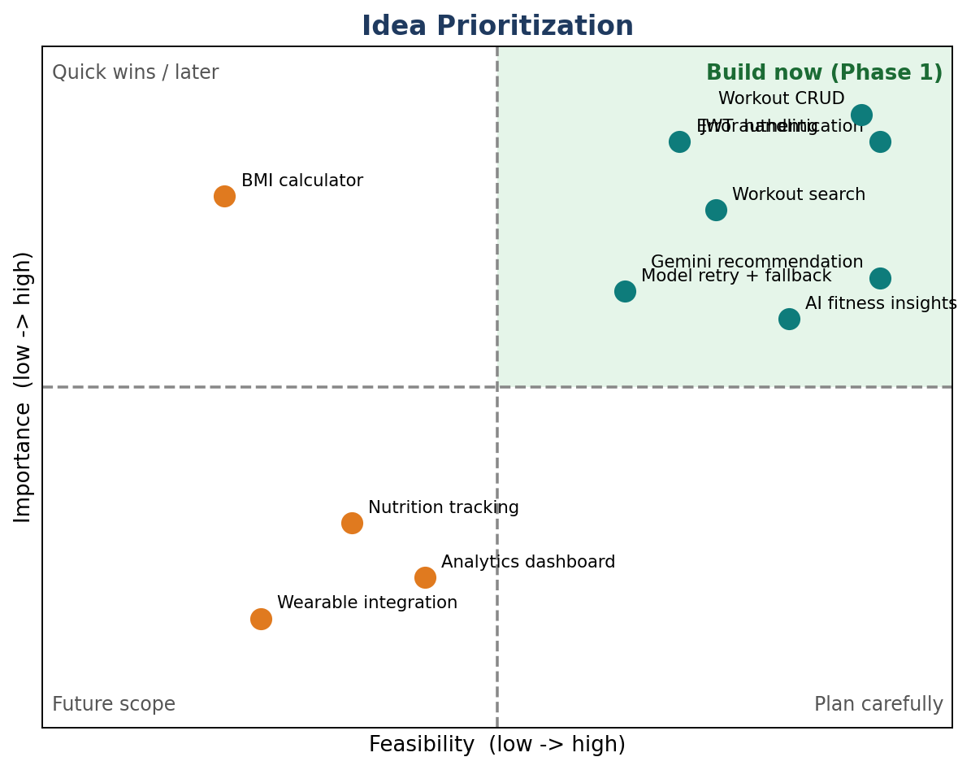
Outcome: ideas in the top-right quadrant (JWT authentication, workout CRUD, workout search, Gemini workout recommendation, AI fitness insights, centralised error handling and model retry/fallback) were selected for the first release of the AI FitTrack API. Nutrition tracking, BMI calculation, wearable integration and an analytics dashboard were kept as future scope.

